ASSIGNMENT-2 DOCKER-[FREESTYLE]
GITHUB

+--------------+--------------+
| | |
Q1 Repo Q2 Repo Q4 Repo
| | |
v v v
Q1-Freestyle Q2-Freestyle Q4-Freestyle
| | |
+--------------+--------------+
|
JENKINS
|
DOCKER
|
+---------+---------+
| | |
Q1 Q2 Q4
| | |
:81 :90 :8080

q1 0.0.0.0:80---81/tcp
q2 0.0.0.0:80---90/tcp
q4 0.0.0.0:8080---80/tcp
AND TEST -------- http://EC2-IP:81
--------- http://EC2-IP:90
---------- http://EC2-IP:8080
1)GIT REPO FOR -2026Q1MR
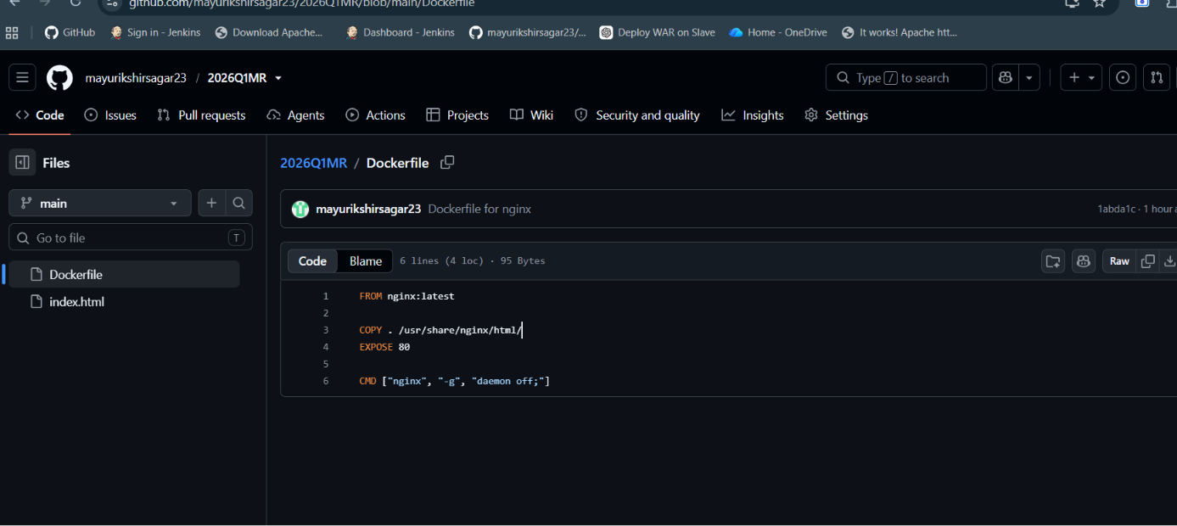
FROM nginx:latest—uses nginx as aweb server.
COPY . /usr/share/nginx/html/----copies your Q1 rpository files inyo nginx website directory.
EXPOSE 80 ---documents that the container uses port 80
CMD ----keeps nginx running
2) DOCKER BUILD-- EXECUTE SHELL COMMMAND
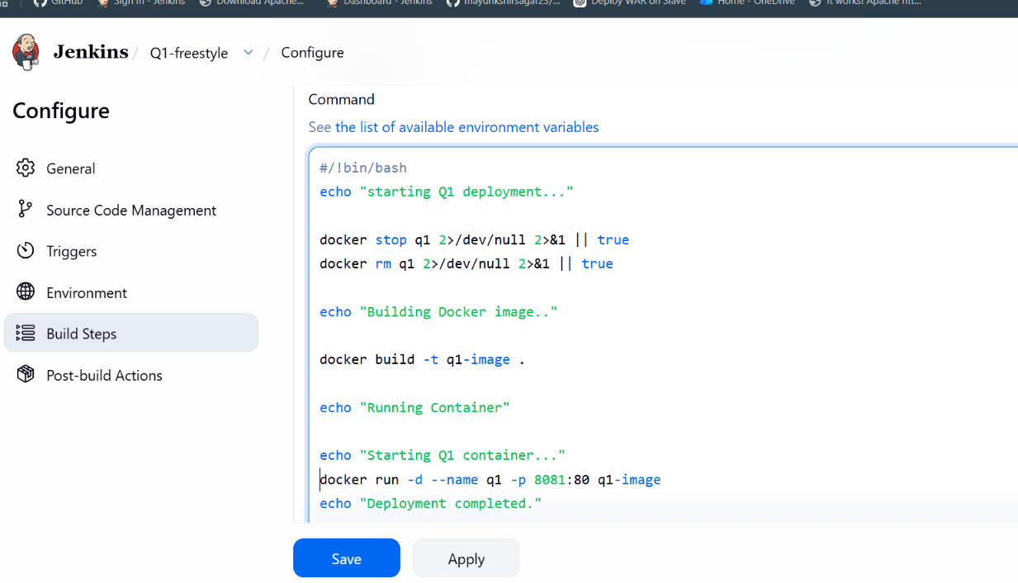
1)docker stop q1 ---- to stop old container
2)docker rm q1----- removes the old container
3)docker build -t q1-image---- builds the docker image using the Dockerfile from the github repository
4) . ---- means build using the current jenkins workspace
5)docker run… --- to start the container
5) EC2 host port Container port
8081 ───────────> 80
Nginx

3)JENKINS -DEPLOYMENT COMPLETED

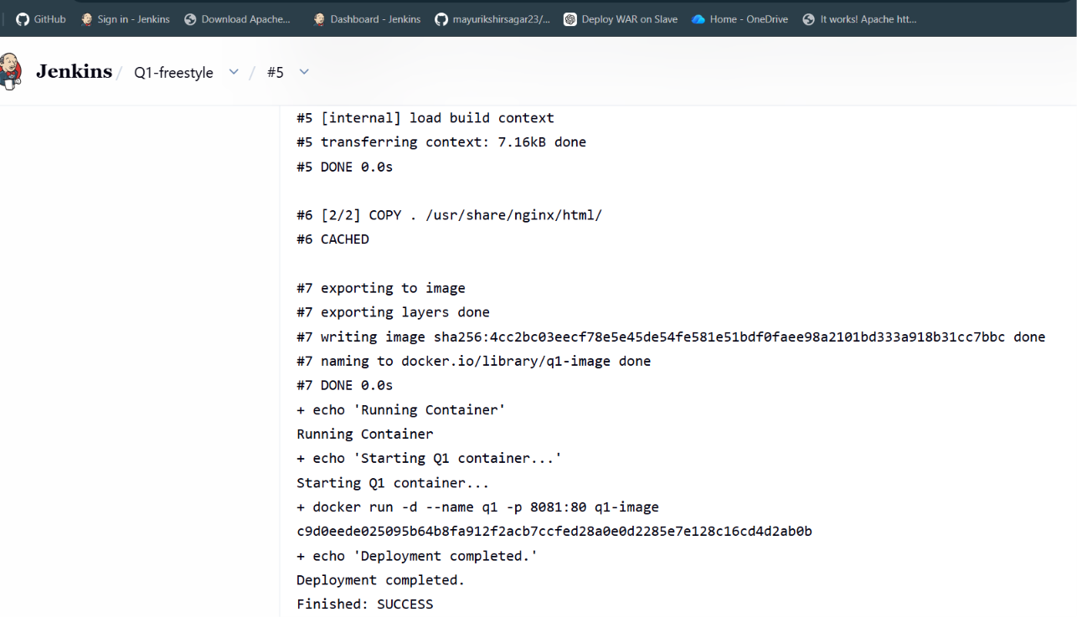
4)EC2-USER
-----Check by using-docker ps -a

